**Systems Level Analysis of Cellular Response to Gemcitabine in Diffuse Large B-Cell Lymphoma**

**Abstract**

Diffuse large B cell lymphoma (DLBCL) is a highly aggressive lymphoid neoplasm with diverse genetic features. While combination chemotherapy is the standard of care, clinical response varies greatly across patients. This is largely due to the heterogenous nature of the disease with different subtypes with unique molecular features that underscore intrinsic resistance or sensitivity to various chemotherapy agents. Yet, not much is known about these molecular features responsible for delineating chemoresistance or chemosensitivity and why different DLBCL patients respond so variably to different regimens of chemotherapy. Managing treatment resistance in DLBCL is therefore a pressing unmet need. By leveraging on the application of a novel proteome-wide screening technology, IMPRINTs-CETSA, we seek to interrogate cellular proteomes of DLBCL for identification of functional protein-protein interactions that will provide novel insight into responses elicited following treatment with active chemotherapy agent gemcitabine, a drug that has shown promising preclinical efficacy for DLBCL treatment. Results from our screen have uncovered a network of 6 key spliceosome proteins as possible factors involved in the sensitization of DLBCL to gemcitabine, potentially through the regulation of alternative splicing. Alternative splicing has indeed been shown to contribute to various cancer-related processes yet its role in DLBCL remains unknown. We hence seek to investigate the potential role of these proteins and their spliceosome effects on gemcitabine sensitivity and through this work, we aim to paint a clearer picture of cellular landscapes underpinning resistance and sensitivity to gemcitabine that will contribute to its effective optimization for DLBCL treatment.

**1. Introduction**

**1.1.1 Diffuse Large B Cell Lymphoma is the most aggressive and prevalent lymphoid malignancy**

Lymphoid neoplasms are haematological malignancies that arise from lymphoid cells at different stages of their differentiation. 5% of all newly diagnosed malignancies are lymphomas (Beham-Schmid, 2017). Depending on the particular lymphocyte involved, such lymphoproliferative disorders are categorised into Hodgkin Lymphoma (NL) or Non-Hodgkin Lymphoma (NHL). Prognosis of HL is generally excellent and patients are easily cured through a combination of chemotherapy and radiotherapy. Compared to HL where subtypes are few, NHL represents a more heterogeneous group of lymphoproliferative malignancies with poorer prognostic outcomes. The current World Health Organisation classification of lymphoid neoplasm describes over 40 categories of NHL and only 5 clearly defined categories of HL (Beham-Schmid, 2017). Incidence rates of NHL was ranked 8th in Singapore in 2018 (Singapore Globocan, 2018) and 7th as one of the top 10 cancers for incidence and mortality in the US in 2019 (National Cancer Institute, 2019). As of 2021, an estimate of 77240 new NHL cases were reported in the US.

Of the lymphoid malignancies, diffuse large B cell lymphoma (DLBCL) is the most prevalent and accounts for 30 – 40% of all NHL cases. DLBCL arises from clonal expansion of lymphoid cells at the germinal or post-germinal stage. Alongside being most common, DLBCL is also the most aggressive type of high-grade lymphoma primarily driven by gene rearrangements of *MYC, BCL2,* and/or *BCL6* (Teras et al., 2016)*.*

**1.1.2. DLBCL is extremely heterogenous and classification efforts have not yet had significant clinical impact**

Ongoing efforts across the past decade continue to demonstrate the extreme heterogeneity of DLBCL. The Cell-of-Origin (COO) classification - reported through gene expression profiling (GEP) of DLBCL – is one of the longstanding and earliest system of DLBCL classification. Two main subgroups of DLBCL were characterised in accordance with the COO: the germinal centre B cell (GCB) and the activated B cell (ABC) (Beham-Schmid, 2017). The ABC subtype is derived from the centroblasts of the germinal center and is characterized by the aberrant activation of NFkB pathways and chronic BCR signalling (Fig. 1x). The GCB subtype is derived from the plasmablasts of the germinal center and is characterized by aberrant PI3K signalling and alterations in chromatin-modifying proteins. Patients with the ABC subtype have generally been identified to have poorer prognostic outcomes. The 5-year overall survival (OS) rate and progression-free survival (PFS) of the ABC subtype is reported to be 58% and 48% respectively as compared to the GCB subtype where OS and PFS are 78% and 73% respectively (Scott et al., 2015). The COO classification of DLBCL is highly recognised and currently still being widely adopted by clinicians for disease diagnosis and prognostication.

Recently, more extensive gene expression and mutational profiling of the disease has led to the discovery of unique genetic disparities within DLBCL to further enable DLBCL subtypes to be identified. Of note, a landmark study has led to the classification of 5 robust DLBCL subtypes that are underscored by their distinct genetic signatures and patterns of somatic mutations (cite Margaret shipp).

Whilst much headway has been made in the understanding of the molecular features of DLBCL, it is likely that genetic heterogeneity extends well beyond the subtypes of DLBCL identified. Whilst classification efforts have provided much meaningful insight into our understanding of DLBCL, this knowledge has not yet significantly impacted clinical care. Successful treatment strategies are yet to be guided by this information and marked biological and clinical variability between patients still exists.

**1.1.3. Chemotherapy is a Mainstay for DLBCL Treatment**

In more recent years, a new paradigm for the treatment has emerged as a curative third-line treatment for DLBCL patients – the application of the chimeric antigen receptor T cell therapy (CAR-T). However, a major limitation to the effective deployment of CAR-T include life-threatening CAR-T cell-associated toxicities. Particularly, the toxicity profile of CAR-T therapy includes cytokine release syndrome (CRS) and immune effector cell-associated neurotoxicity syndrome (ICANS), a widely reported side effect from DLBCL clinical trials. Furthermore, whether CAR-T is the efficacy of CAR-T remains to be proven and its high cost and the scarcity of treatment providers are major barriers that render the therapy inaccessible to the general populace While advancements in the domain of immunotherapy are being made, combination chemoimmunotherapy will withholds as the standard of care for the first and second-line treatment of DLBCL.

R-CHOP, a combination of chimeric monoclonal antibody Rituximab, and chemotherapy agents cyclophosphamide, doxorubicin hydrochloride, vincristine, and prednisone serve as the front-line treatment for DLBCL. Under the R-CHOP regimen, complete remission is observed for up to 50% of patients while the remainder of patients are either initially refractory or are prone to eventual relapse (R/R) (Beham-Schmid, 2017). Where R-CHOP is inefficacious, the second line of care entails the treatment of patients with an assortment of high-dose salvage chemotherapy regimens followed by consolidative autologous stem cell transplant (ASCT). Prognosis of these patients however, remain extremely poor with 5 year survival rates of less than 20% (Nabhan et al., 2018). Numerous efforts have been made to improve the efficacy of these chemotherapy regimens, for example, through supplementation with novel agents or dose intensification (He & Kridel, 2021). Results have however, generally failed to demonstrate significant clinical benefits.

**1.1.4. Chemoresistance and non-sensitivity are major determinants of R/R DLBCL treatment failure**

Characteristic of R/R DLBCL, intrinsic chemoresistance or the acquisition of chemoresistance over the cause of treatment are the most likely determinants of chemotherapy inefficacy. factors responsible for such non-chemosensitive conditions render chemotherapy ineffective and remains a major cause of treatment failure and DLBCL mortality (Ramos & Bentires-Alj, 2014). Overcoming chemoresistance therefore remains a perennial challenge to be addressed in the treatment of R/R DLBCL. It is therefore imperative that mechanisms underpinning the vastly varied R/R DLBCL response to chemotherapeutics be more thoroughly investigated. Where gene expression and pathological profiling has enabled the systematic classification of DLBCL, actionable clinical insight has yet to materialise and the key molecular features known to contribute to differences in outcomes of clinical course remain limited.

One reason for our lack of understanding into treatment resistance for regimens used in DLBCL is because many successful combination chemotherapies such as R-CHOP have been developed empirically and are rarely subjected to detailed mechanistic study (He & Kridel, 2021). As such, explanation of pharmacological principles underlying treatment resistance to such multi-agent regimens remain largely elusive. Moreover, when it comes to combination chemotherapy, many studies focus on the synergistic effects of drug combinations instead of individual drug effects. For this reason, individual drug effects are poorly distinguished. In the case of R-CHOP, it was found that the five drugs to not show synergistic interactions but instead, very low cross resistance (Palmer, Chidley & Sorger, 2019).

**1.2. Gemcitabine-based regimens show great promise for treatment of R/R DLBCL**

In the context of R/R DLBCL treatment, staple combination chemotherapy regimens include R-ICE Rituximab, Ifosfamide, Carboplatin, and Etoposide), R-DHAP (Rituximab, Dexamethasone, Cytarabine, and Cisplatin), R-GDP (rituximab, gemcitabine, cisplatin, and dexamethasone), or R-GemOx (Rituximab, Gemcitabine, Oxaliplatin). Of the common agents employed, gemcitabine containing regimens are increasingly being favoured and recognised owing to their more favourable toxicity profiles. In fact, R-GemOx is considered one of the most effective salvage regimens for ASCT ineligible patients

Gemcitabine is an anti-neoplastic pyrimidine analog that replaces cytidine during DNA replication (de Sousa Cavalcante & Monteiro, 2014). Being a produg, gemcitabine must be metabolised into its active phosphorylated form within cells in order to exert its effects. When active, gemcitabine binds DNA to block new nucleosides resulting in growth inhibition of cells. Gemcitabine also depletes dNTP pools by binding to its target ribonucleotide reductase (RRM1) (de Sousa Cavalcante & Monteiro, 2014). Collectively, these processes culminate in apoptosis yet how this happens is unclear and the relative importance of each of these pathways remains to be resolved. Gemcitabine is used in various other carcinomas including non-small cell lung cancer, pancreatic cancer, bladder cancer and breast cancer and is further being investigated for use in oesophageal cancer (de Sousa Cavalcante & Monteiro, 2014). Currently, gemcitabine is being used experimentally in lymphoma and is proving to be efficacious in treatment of DLBCL patients of older age that may be unable to endure more potent high-dose chemotherapies. In fact, R-GemOx is considered to be one of the most effective salvage regimens for ASCT ineligible patients. Why gemcitabine is effective for DLBCL has not yet been well characterised and its mechanisms of resistance in DLBCL is even less well understood. Furthering our understanding of gemcitabine responses will be necessary in guiding therapeutic use of this drug for DLBCL treatment in the R/R setting.

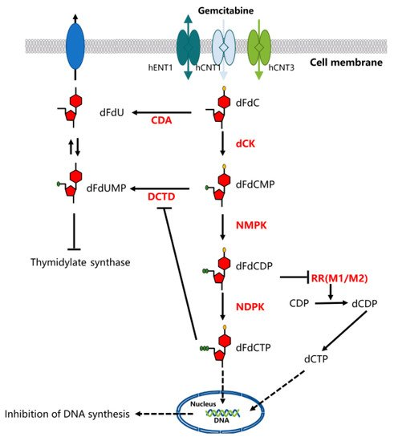

**Fig.1. Gemcitabine Metabolism and Mechanisms.** Gemcitabine is a prodrug that requires cellular uptake and intracellular phosphorylation in order to exert its action. Once administered, gemcitabine is transported into cells by nucleoside transporters. Gemcitabine is then phosphorylated into gemcitabine monophosphate, diphosphate, and triphosphate. In its triphosphate form, gemcitabine binds DNA and inhibits DNA synthesis. In its diphosphate form, gemcitabine potently inhibits ribonucleotide reductase, resulting in a reduction of deoxyribonucleotide pools necessary for DNA synthesis.

**Summary**

Challenges in DLBCL management remain in attempting to reduce toxicity of treatments, prolong disease-free survival, and in the determination of biomarkers that can predict patient outcomes or responsiveness to the assortment of DLBCL treatments available.Optimization of DLBCL treatment thereby necessitates the continual optimization of combinatorial chemotherapy regimens to make them more efficacious alongside further stratification of patients in accordance with their responses (Beham-Schmid, 2017). Toward that end it is therefore pertinent that efforts be put into interrogation of individual chemotherapy components such as gemcitabine for the evaluation of cellular responses upon treatment in order to glean actionable clinight insights for overcoming treatment resistance in R/R DLBCL. My project therefore seeks to investigate and evaluate the cellular responses of DLBCL elicted by gemcitabine treatment in order to identify factors responsible for sensitivity and non-sensitivity alike.

**2. Application of IMPRINTS-CETSA for Uncovering Novel Protein Nodes Contributing to Gemcitabine Resistance and Sensitivity in DLBCL**

Much of our knowledge pertaining to the genetic lesions and molecular features characteristic of DLBCL hail from methods that are genome-centric such as whole exome sequencing and gene expression profiling.

Why study proteome blabla

how entire cellular proteomes respond and what functional protein-protein interaction could contribute to different pharmacological mechanisms of drug outcomes is poorly understood.

Many types of information cannot be obtained from the study of genes alone. For example, proteins, not genes, are responsible for the phenotypes of cells. It is impossible to elucidate mechanisms of disease, aging, and effects of the environment solely by studying the genome. Only through the study of proteins can protein modifications be characterized and the targets of drugs identified.

Proteins are essential molecules in nearly all biological processes. They provide the structural scaffolding in cells and function in myriad processes such as metabolism, biosignalling, gene regulation, etcetc. Abnormal regulation of protein function is one of the most promiment factors in disease pathologies.

RNAseq etc is insufficient to infer protein abundance

**2.1. Functional Protein Interactions Provide Unprecedented Insight Into Drug Response**

A large number of drug candidates have failed in clinical trials because of insufficient interpretation into their functional pharmacological principles (Morgan et al., 2012). This holds true for many chemotherapy agents currently undergoing clinical trials for the treatment of R/R DLBCL. For their effective application toward combination chemotherapy regimens, it is imperative that parameters such as target engagement and the functional pharmacological response of each chemotherapy agent be properly verified in order for their efficacy and toxicity to be properly assessed.

Beginning with target engagement with primary and/or off-targets, many drugs, through indirect measure, can elicit various inconspicuous downstream effects through the functional modulation of protein-protein interactions. Interactions between proteins and other molecules within cells are therefore major determinants of their function and activity. These interactions are responsible for execution of protein activity, recognition of substrates, determination of protein localization, membership in protein complexes, and even nucleic acid/metabolite recognition (Dai et al., 2019). The term protein interaction states (PRINTs) has thus been used to describe the profile of interactions between proteins and their principle partners (Dai et al., 2019). The PRINTs of any given protein are context-dependent and can be dynamically rewritten as dictated by the physiology of the cell (Fig. 2) (Dai et al., 2019). The functional modulation of PRINTs within DLBCL proteomes in response to gemcitabine could therefore provide unprecedented insights into the inner-workings of drug resistance and sensitivity (Dai et al., 2019).

Changes in PRINTs are usually accompanied by a change in the melting temperature of a protein thereby resulting in detectable thermal shifts. These thermal shifts can be detected by a powerful and novel biophysical technique known as the Cellular Thermal Shift Assay (CETSA).

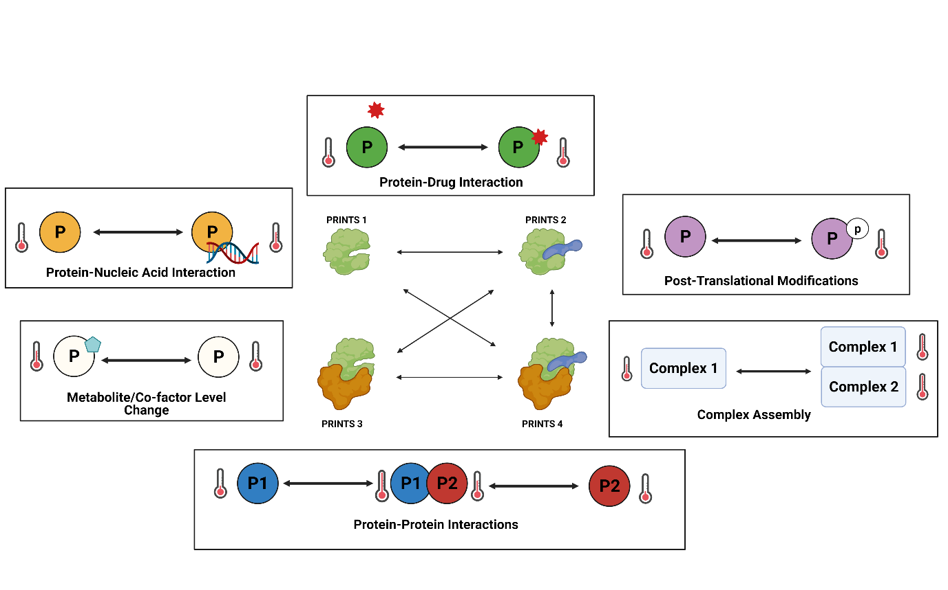

Fig. . PRINTs describe the current state of a protein through its interactions with other molecules. Figure adapted from (Dai et al., 2019). Physiological processes such as protein drug interaction, post-translational modifications, gain or loss of membership within protein complexes, simple protein-protein interactions, cofactor binding, and nucleic acid binding. Changes in PRINTs are accompanied by detectable changes in the melting temperature of a protein

**2.2. CETSA Enables the Interrogation of Protein-Ligand Interactions by**

Initially designed for the study of drug-protein interactions, the Cellular Thermal Shift Assay (CETSA) technique has thus emerged as the first technology that has made possible the *in situ* monitoring of the modulation of PRINTs. The CETSA technique capitalises on the principle of ligand induced thermal stabilisation where the effective engagement of a protein with its cognate targets increases its melting temperature thereby rendering it increasingly stable (Molina et al., 2013). With CETSA, experiments are modelled to obtain a proteins melting curve or isothermal dose response fingerprint (ITDRF), both of which can be employed for the direct measurement of intracellular target engagement (Molina et al., 2013). Where lysate CETSA experiments provide information about direct target engagement, intact-cell CETSA protocols provides more expansive information beyond direct target engagement and reports on indirect cellular processes that could affect target the thermal stability of proteins under physiological conditions such as but not limited to, protein-protein interactions, post translational modifications, and sub-cellular relocalisations.

**Fig. 2. Principles of the Thermal Shift Assay.** Thermal shift assays measure the change in a protein melting behaviour in the presence of a ligand – a small molecule that binds to the protein. Proteins are normally well folded and organised in order to perform their function. When heat is applied, they begin to denature, aggregate, and precipitate. The ligand can delay/accelerate or have no effect on the denaturation process. If it delays the process, the melt curve shifts toward the right.

**2.2.1. IMPRINTs-CETSA Enables the Study of Proteomes in a Proteome-Wide Format**

More recently, CETSA has been expanded to enable the profiling of protein stability changes in a proteome-wide format through its integration with quantitative mass-spectrometry based technologies for a variety of different applications (Friman, 2020). The first instance of the technology was used in the study of global protein stabilities under a single condition of drug treatment. From it, a novel off-target was found for HDAC inhibitor Panobinostat (Becher et al., 2016). The technology has since rapidly expanded to enable the interrogation of proteomes across multiple contexts where PRINT profiles are comparatively integrated. The comparative modulation of PRINTs and their thermal profiles between different cellular states and contexts is thus referred to as IMPRINTs (Fig. 1d) and this multidimensional technology has come to be known as IMPRINTs-CETSA. From the IMPRINTs profile of a protein, information pertaining to its **abundance** and **thermal stability** can be gleaned on a proteome-wide level and meaningfully interpreted across different conditions and cell states (Dai et al., 2019).

IMPRINTs may provide novel perspectives into drug action. One advantage of studying drug action through IMPRINTs is that early proteomic response can be effectively detected. After all, proteins are the key targets of drugs and it is the cellular proteome that first responds to drug treatments where changes in transcriptomic programs are yet to execute. In addition, even if the primary targets of a drug are known, further light can be shed unto its pharmacological mechanisms of action, including any effects on its primary, downstream, and off-targets to therefore provide new perspectives into the mechanistic underpinnings of drug action, especially in the context of cancer where the operative function of PRINTs could vary considerably between resistant and sensitive cell types. PRINTs for the action of drugs at early or late time points will reveal a myriad of novel modulations of interactions in the cell, some of which might serve as biomarkers for efficacy or resistance development or constitute novel therapeutic targets (rephrase).

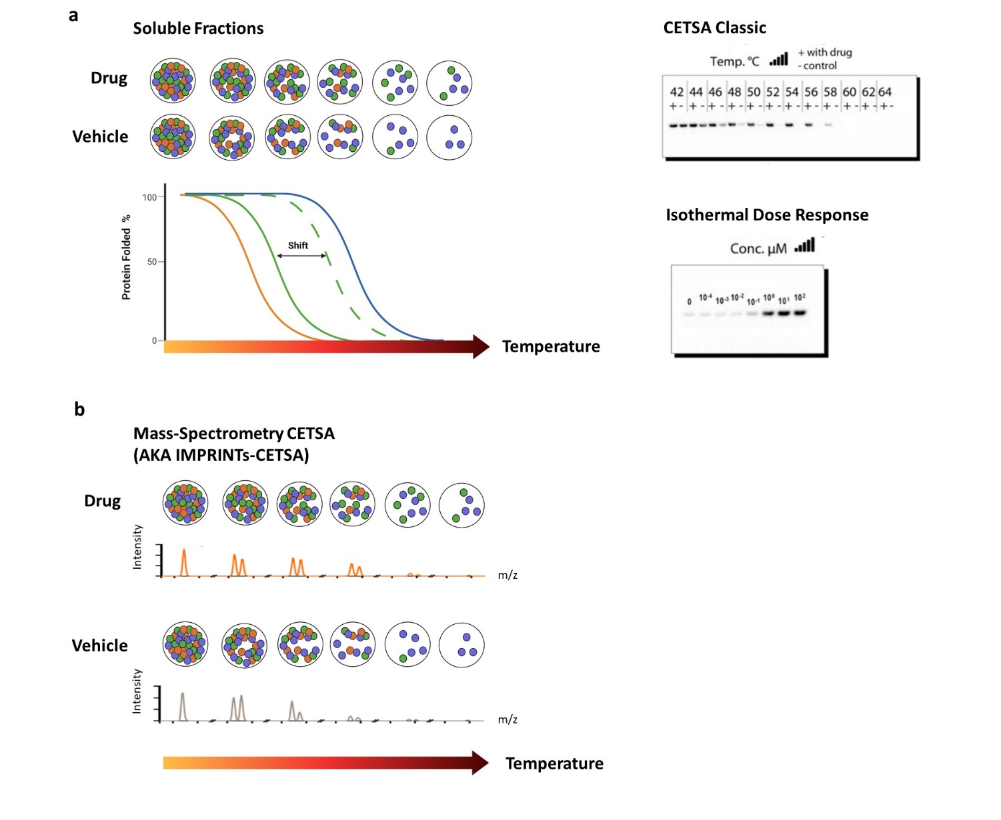

**Fig. 3.** **CETSA** **(a)** Within a cell, there are mixed population of proteins with different melting profiles. When cells are subject to heating, soluble fractions obtained after lysis can be similarly assayed for detection of a thermal shift. **(b)** By coupling CETSA with mass spectrometry, thermal shifts can be surveyed in a proteome wide format.

**2.3. IMPRINTs-CETSA Screen**

We hence aim to study drug response of individual chemotherapy agents through the application of IMPRINTs-CETSA that will enable the interrogation of cellular proteomes of DLBCL and how they respond to gemcitabine. We seek to interrogate cellular proteomes of DLBCL in order to identify key protein nodes that could suggest core differences in mechanisms of drug resistance and sensitivity. We envisage that discrepancies in IMPRINTs profiles between conditions of chemosensitivity and chemoresistance will enable the identification of novel pathway vulnerabilities that can be specifically targeted to enhance anti-tumour responses in DLBCL. Our work with IMPRINTs will therefore provide meaningful inroads towards furthering our understanding of molecular pathways implicated in gemcitabine-related drug resistance and sensitivity. A better understanding of individual drug action within these contexts is paramount for effectively guiding patient treatment. Furthermore, IMPRINTs may reveal proteins that could serve as novel biomarkers or therapeutic targets. The wider implications of our work will be the Improvement of treatment for R/R DLBCL patients by aiding in identification of patients that will benefit from different combinations of chemotherapy.

**2.3.1. A preliminary chemotherapy screen identified gemcitabine sensitive and resistant DLBCL lines**

From an initial viability screen of several DLBCL cell lines subject to treatment with single chemotherapy agents, gemcitabine response was found to be variable across the cell lines with 5 out of 14 lines observed to be highly resistant to gemcitabine with half maximal inhibitory concentrations (IC50) of more than 100uM (Fig. x). From the screen, 2 sensitive cell lines (OCI-LY19 and OCI-LY3) and 2 resistant cell lines (SUDHL4 and HT) were chosen for IMPRINTs-CETSA with considerations into their subtyping (Fig. sx). The dose response curves of the chosen 4 cell lines is illustrated in Fig. x. For the IMPRINTs-CETSA screen, it was determined that a factor of 20X the 48h IC50 would be used for treatment. This gemcitabine concentration used for the IMPRINTs-CETSA screen will henceforth be referred to as the CETSA concentration.

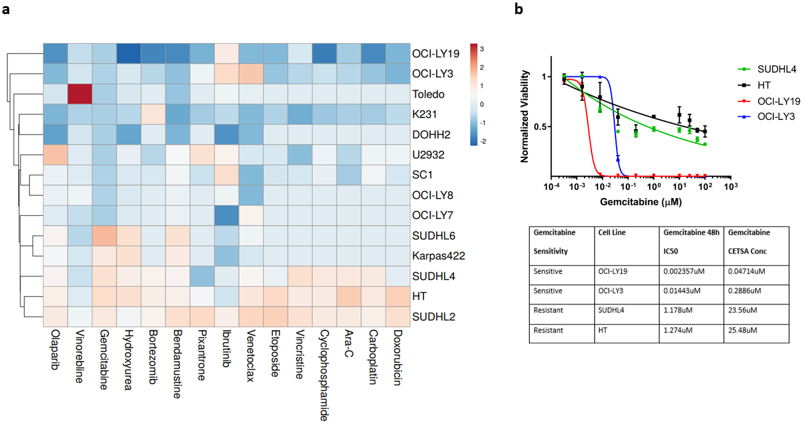

**Fig. x.** General sensitivity of cell lines in the ADJ lab to common chemotherapy agents. Cell lines subject to 48h of treatment with single chemotherapy agents and cell viability was assayed. IC50 values were generated and plot as a heat map. IC50 values ln(x+1) transformed. Euclidean clustering of cell lines was carried out using their IC50 values. Fold change indicated in the legend. **(b)** Gemcitabine dose response curves andIC50 values of our 4 chosen lines at 48h of treatment.

**2.3.2. Experimental design of the IMPRINTs-CETSA screen**

In order for thermal stability changes to be accurately detected in response to perturbations by drug treatment, it is necessary for the drug to accumulate within cells. This ensures that biochemically, there will be a maximum occupancy of all intended drug targets, as well as off-targets, such that related downstream processes are elicited and their accompanying thermal shifts captured.

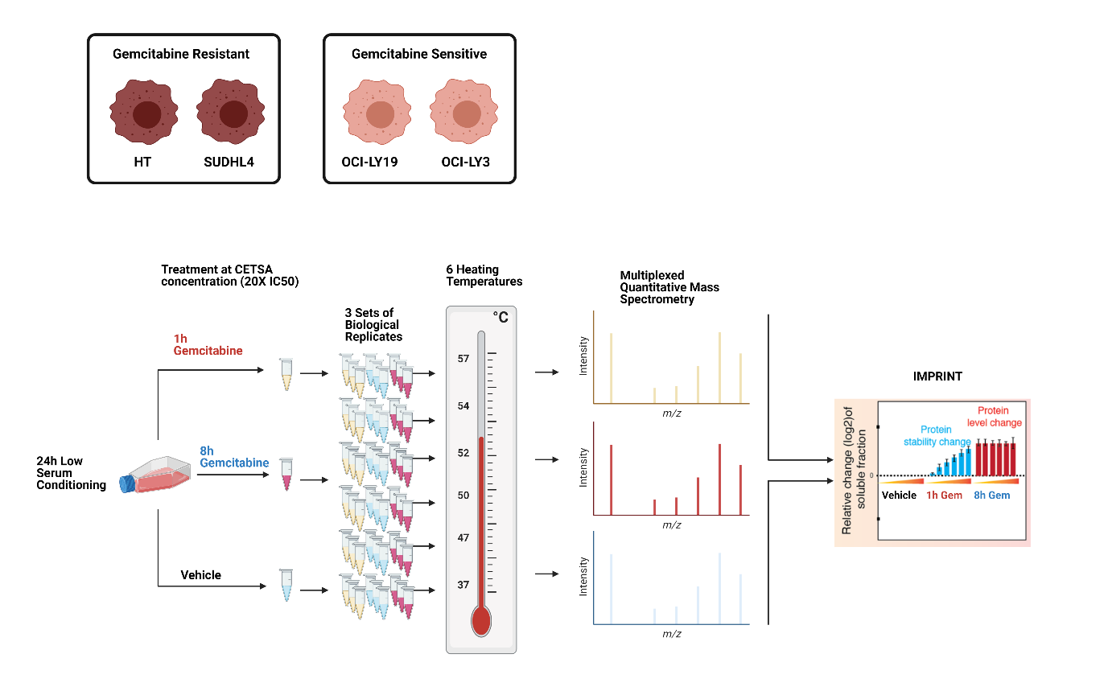

**Fig. x.** . The four cell lines were treated with CETSA concentration of gemcitabine. The high drug concentration is necessary for saturation of target engagement by the drug. Cells were treated with gemcitabine at an early 1h timepoint and 8h timepoint after an initial 24h of conditioning in low serum. The low serum conditioning was necessary to prevent serum proteins from interfering with the max occupancy of gemcitabine to its targets. N=3 for each cell line.

**2.3.3. Thermal shifts in RRM1 following gemcitabine treatment validates IMPRINTs-CETSA**

As a positive control for our screen in order to ensure that our cells were effectively uptaking and responding to gemcitabine, we performed targeted CETSA experiments on RRM1 in order to validate that gemcitabine is indeed effectively being up-taken and processed by our cell lines. Since RRM1 is a known target of gemcitabine, it is expected to be stabilised under gemcitabine treatment and will serve as a proxy for the accumulation of gemcitabine within cells. Furthermore, as gemcitabine is a pro-drug, it will have to undergo physiological processing in order to enter an active conformation in order for binding to RRM1 to be possible. This suggests that indeed, gemcitabine is indeed binding to its canonical target as intended and that the screen accurate….. In order to confirm this, all four cell lines were treated under the same biochemical conditions as the IMPRINTs-CETSA for a duration of 2 hours, subject to heating at 58°C, and the thermal shifts of RRM1 was quantified through western blot analysis. From the generated ITDRF of RRM1, we observe that as gemcitabine dose increases, RRM1 becomes increasingly stable, thereby confirming that gemcitabine is indeed being up taken into our cells and metabolised into its active conformation capable of engaging and stabilising RRM1 for all four cell lines (Fig. x).

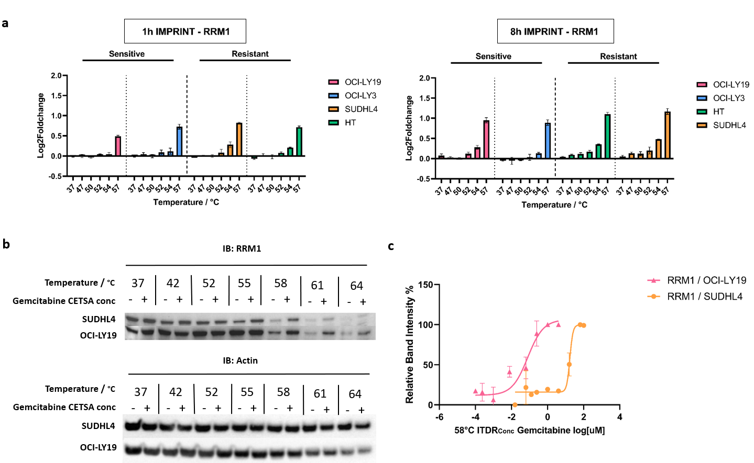

Fig. x. (b) CETSA classic. n = 3 (c) n = 3

Figure 1

**2.3.4. Gemcitabine response is not attributed to differential gemcitabine uptake**

Effective drug transport results in dramatic accumulation of the drug in cells, which is a key factor of a drugs therapeutic efficacy. This is especially applicable to nucleoside analogs such as gemcitabine where their efficacies heavily rely upon their effective entry into the cell in order to exert their effectiveness. Interestingly, we observed from the preliminary ITDRF of RRM1 that max occupancy of RRM1 for our sensitive cells occurs at much lower doses of gemcitabine than resistant cells. Since resistant cells respond to a much higher dose of gemcitabine, we wanted to account for any potential difference in gemcitabine uptake across our 4 cell lines.

It has been reported that expression levels of the hENT1 transporter serve as a predictive biomarker for gemcitabine treatment outcomes and that hENT1 expression is a determinant of gemcitabine sensitivity in non-small cell lung cancer and pancreatic adenocarcinoma (Nordh, 2014). In fact, favourable patient survival is associated with higher levels of hENT1 and hCNT1 transporters. We therefore asked if the occupancy of RRM1 at lower doses of gemcitabine from our sensitive lines could be attributed to an increase in amount of hENT1 and hCNT1 transporters and that if the expression levels of these transporters could contribute to the discrepancies in gemcitabine response. From RT-qPCR analysis of hENT1 and hENT3 expression levels, there does not seem to be a significant difference in basal expression across our 4 cell lines. Surprisingly, upon gemcitabine treatment no significant increase in expression levels of CNT1 and ENT1 were observed for the sensitive lines whereas the expression levels of these genes increased at least 2 fold for the resistant lines. Furthermore, the increase in CNT1 gene expression levels corroborates the increase in CNT1 protein levels (Fig. xa, xc). Where an increase in gemcitabine uptake could be a possible determinant of gemcitabine sensitivity, our results suggests that the sensitivity observed from our sensitive cell lines is likely not a result of enhanced uptake. It is therefore likely that differences in uptake of gemcitabine is not a mechanism responsible for gemcitabine resistance or sensitivity between our cell lines. So our protein nodes more important blablalbalb

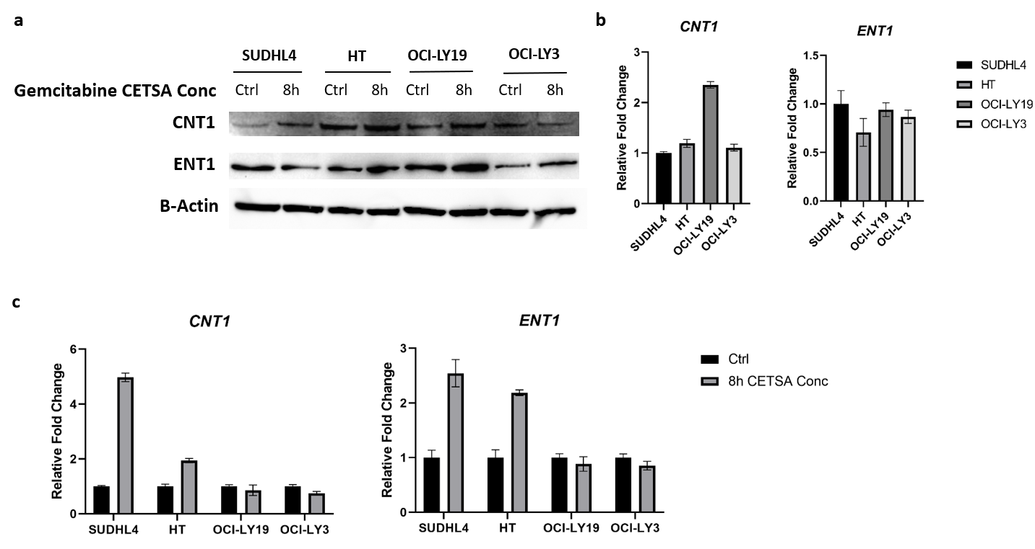

Figure 2. GET SIGNIFICANCE FOR QPCR

**2.4. Discussion**

For the first time, IMPRINTs-CETSA allows for a quantitative global assessment of how cellular proteomes of DLBCL respond to chemotherapy. However, there are some caveats to the CETSA technique. The extent of thermal stabilization depends not only on the affinity of the ligand, but also on the melting thermodynamics of the native protein. Not good for membrane proteins. There exists proteins that are extremely thermally stable or unstable. These proteins are dubbed CETSA blind proteins and no detectable thermal stability changes can be quantified.

Now we study sensitivity and resistance blablalblbabl

**3. Investigating the Biology of Gemcitabine Sensitive Lines**

Why study sensitivity blablalblabalb

**3.1. Sensitive lines are markedly more apoptotic than resistant lines**

It has been reported that early shifts from proteins in apoptotic pathways and cellular stress response have been observed for cancer cells exposed to anti-cancer drugs (Pfeffer & Singh, 2018) and this response to gemcitabine is not surprising. Expectedly, upregulation of these pathways were observed in our sensitive but not resistant lines which is in good agreement with the responsiveness of our lines to gemcitabine. To validate these pathways from our IMPRINTs and sequencing analyses*,* annexin V/PI staining was carried out in order to quantify the amount of apoptotic cells in response to gemcitabine treatment along with immunoblotting assays for known apoptotic markers cleaved PARP1 and cleaved caspase 3. In addition to our main 4 cell lines, 4 alternative cell lines, two of which are sensitive and two of which are resistant, were chosen from the panel of cells from our chemotherapy viability screen in order to further extend the validity of our results. Our annexin V/PI staining results show that for treatment durations of 1 and 8 hours, larger populations of apoptotic cells are observed from sensitive lines (Fig. 6a). Furthermore, clear cleavage of caspase 3 and parp1 are detected from sensitive lines. Collectively, through two separate assays,our data confirms that indeed, resistant cells exhibit marked less apoptosis in response to gemcitabine treatment as compared to the sensitive lines. This marked increase in apoptosis in sensitive lines is further recapitulated through the similar detection of cleaved caspase 3 and cleaved parp1 in our four alternative lines (Fig. 6b).

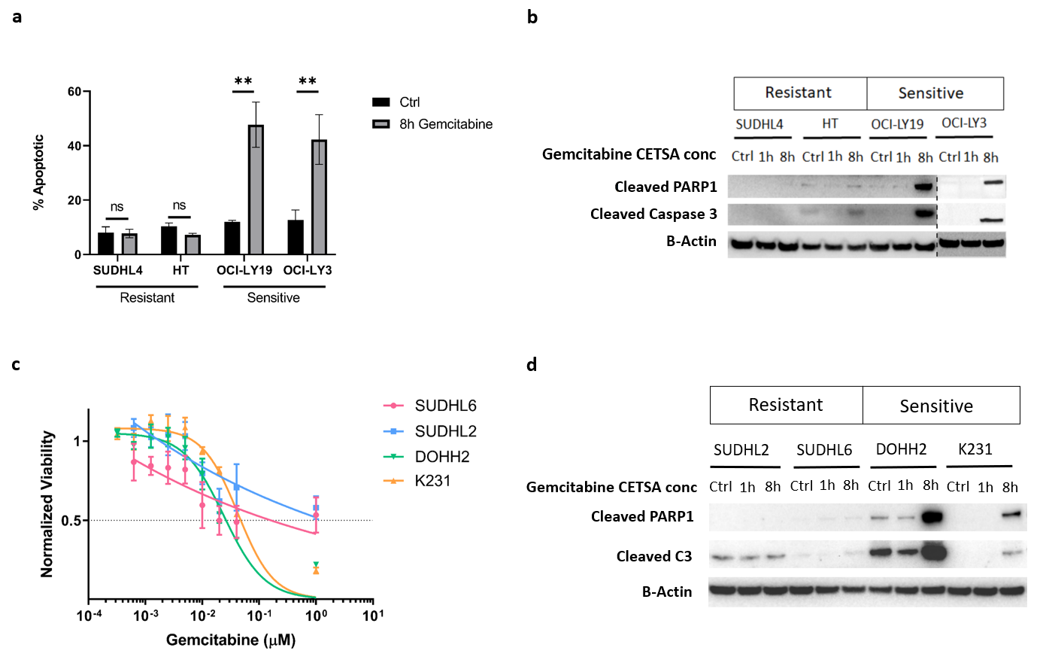

**3.2. Sensitive lines arrest at G1 under CETSA concentrations**

As expected from the known function of gemcitabine inhibiting DNA replication, we observe that, through PI staining and measurement of DNA content of gemcitabine treated cells, sensitive cells stall at G1 of their cell cycle progression whereas resistant cells do not (Fig. 6c). Collectively, we have shown that sensitive cells respond to gemcitabine treatment with cell cycle arrest and apoptosis while their resistant counterparts.

Blabla talk more about gemcitabine cell cycle arrest blabla

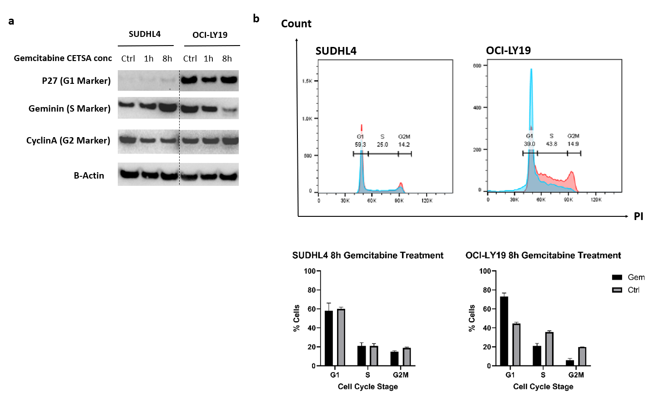

**3.x. RNA Splicing Mechanisms could be Responsible for Gemcitabine Sensitivity**

The spliceosome is composed of 5 snRNPs and more than 150 proteins, including kinasaes, phosphatases, & helicases, many of which are required for spliceosomal function, as well as associated proteins such as mRNA export factors and transcription factors (Matera & Wang, 2014). It is indeed one of the most complex of macromolecular machineries.

In recent years, we are increasingly becoming more aware of aberrations in the splicing machinery and how novel mutations in the splicing components are increasingly being implicated in specific neoplasms. Alternative splicing events are increasingly gaining traction with implications in every single hallmark of cancer (Bonnal, López-Oreja & Valcárcel, 2020). Studies have reported that alterations in the splicing machinery confer many advantages to tumours. For example, through the production of abnormal protein isoforms or skewing of protein isoform ratios, the precarious equilibrium of splice isoforms necessary for normal physiology is perturbed, leading to enhanced tumourigenesis. It has been further reported that alternative splicing can contribute to chemoresistance by modulating the expression or activity of splicing factors required for cell survival through selection of cells that express the repertoire of splicing factors conferring pro survival features. However, it is not yet well understood the extent of damage that a faulty or non-functional spliceosome can cause and it is likely that a dysfunctional spliceosome is only the tip of the iceberg for many cancer related processes. The effects of aberrant splicing can extend way beyond itself through the regulation of a plethora of mis-spliced genes. The spliceosome therefore represents a highly promising targetable anti-cancer therapeutic avenue. Targeting the spliceosome can introduce synthetic lethality, where mutations or changes in expression of splicing factors can sensitize cancer cells to anti-tumour drugs. In addition, changes in the profiles of alternatively spliced isoforms can in part generate or revert resistance to chemotherapy.

**Appendices**

**References**